Sources:

<https://www.gddkia.gov.pl/pl/4234/Stacje-Ciaglych-Pomiarow-Ruchu-dane-z-roku-2019>

<https://gddkia.wandor.pl/raporty_dynamiczne/#/indywidualne/factsheet>

Data from part of Warsaw ringway (bridge), name: “Most gen. S. Grota Roweckiego”.

Characteristic:

5 lanes in one direction.

Maximum allowed official speed 70 km/h, taking into account real situation we assume that maximum possible speed that cars reach is 90 km/h.

Data taken from given Monday of 2020

Total length 300m

Average speed in km/h (hour of the day)

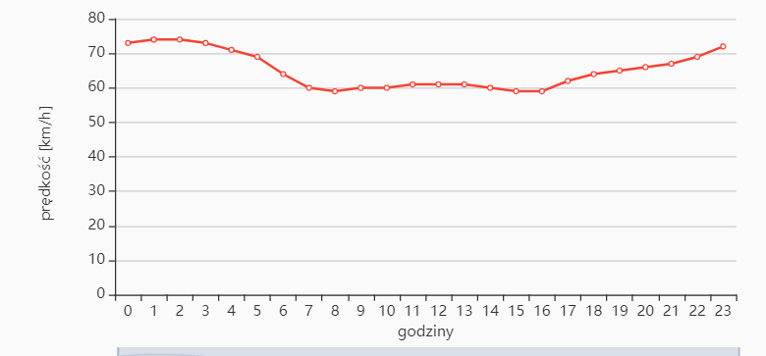

Initial setup of our model that represents given section of a road:

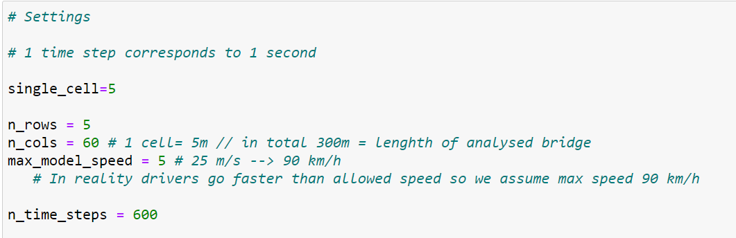

Assuming average speed 60 km/h (speed measured in the middle of the day), average time to cross this bridge is 18 seconds.

At first we find parameters (dawning factor and probability of new car to come up) (task 6) so that our model has the same average time.

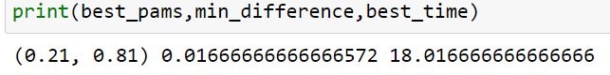

dawning factor= 0.21

probability of new car to come up= 0.81

Amount of cars that went through in given hour (hour of the day)

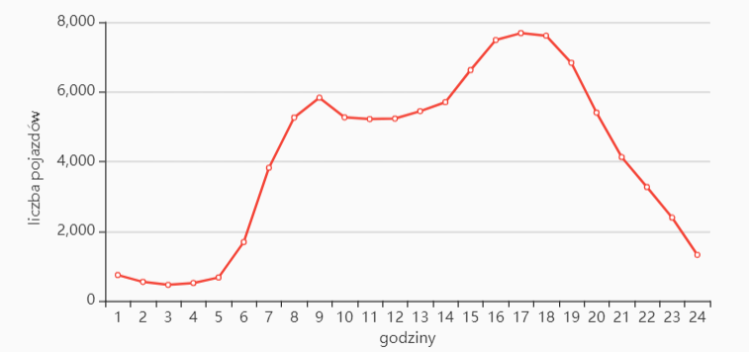

Amount of cars that crossed road section in an hour in our model:

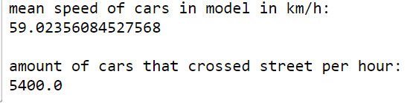

Model gives similar values as real data.